**Exercise 11: Asking Questions**

1. Go online and find out what Ruby's gets.chomp does.

**gets.chomp is used to get string input. It is a string classs method in ruby. gets.chomp takes input from the user through the keyboard and store it in the variable. The purpose of chomp is to remove the newline character at the end of strings.**

1. Can you find other ways to use it? Try some of the samples you find.

**puts "This is how to get integer and float value from user"**

**print "Enter the value to add : "**

**a = gets.chomp.to_i**

**print "Enter the another number to add: "**

**b= gets.chomp.to_i**

**print "Enter the next value to add: "**

**e= gets.chomp.to_f**

**c = a+b+e**

**puts "The Addition Value is \"#{c}\"."**

**puts "a variable is #{a.class}"**

**puts "b variable is #{b.class}"**

**puts "c variable is #{c.class}"**

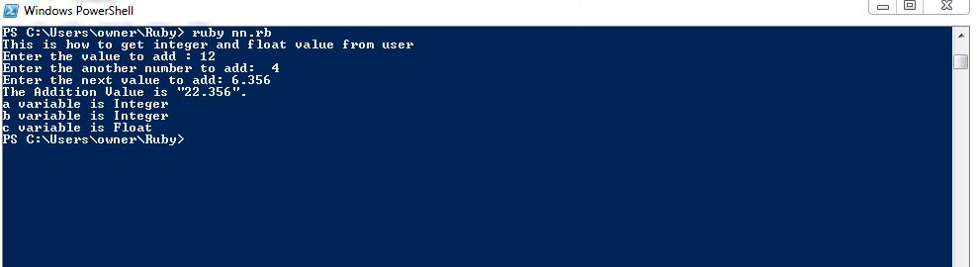

1. Write another "form" like this to ask some other questions.

**puts "Enter Your Name: "**

**name = gets.chomp**

**puts "Enter Your Current Location: "**

**location = gets.chomp**

**puts "Which degree you have completed: "**

**degree = gets.chomp**

**puts "You are #{name} in #{location} and you have completed #{degree}..."**

